|  |
| --- |
| **DyROS Humanoid Robot Structure** |
|  |
| ***A report submitted in partial fulfilment of the***  ***requirement*** ***for the award of degree of***  ***BACHELORS OF ENGINEERING***  ***in***  ***ELECTRONICS AND COMMUNICATION ENGINEERING*** |
|  |
| ***By*** |
| **Kamlesh Kumar**  ***16BEC1047*** |
|  |
| ***under the guidance of*** |
|  |
| **Dr Paras Chawla**  **HOD-ECE** |
| **Electronics And Communication Engineering**    **UIE, Chandigarh University** |

**Table of Contents**

**Chapter** **1.** **Problem Identification**Error: Reference source not found

1.1 AbstractError: Reference source not found

1.2  Scope of Project

1.3 Feature FinalizationError: Reference source not found

**Chapter 2****.** **Design Flow**Error: Reference source not found

2.1 Design Model Error: Reference source not found

**Chapter 3. Simulation and outcome**

3.1 Existing System

3.2 Proposed System

3.3 Methodology

**Chapter 4 Requirement and Specifications**

4.1 Hardware Specifications

4.2 Software Interface

**Chapter 5 System Design**

5.1 Overall circuit Design

5.2 Project Hardware

**Chapter 6. Conclusion and future scope**

**Chapter 7.** **References (If Any)**23

**Chapter 8. Cost Analysis**

**Acknowledgment**

I really appreciate that I have such an opportunity to express my great gratitude and respect to people who helped me when I prepared my BE project. Without their supports and encouragements I cannot go so far.

It is difficult to overstate my greatest gratitude to my project mentor Dr Paras Chawla HOD, ECE Department. First, I would like to thank him for their patient guiding and inspiring throughout my study period. Secondly, I highly appreciate their encouragement and support in my project work, which helped me build confidence and courage to overcome difficulties. Finally, I am grateful for their great insight and suggestions and sharing so much time in project completion. I would have been lost without their support.

I am as ever, truly and deeply indebted to Prof. (Dr.) S. S. Sehgal, Executive Director & Director Engineering, Prof. (Dr.) Ruchi Singla, Associate Director Engineering and Prof. (Dr.) Paras Chawla, Head of ECE Department for their great supports at every stage of my academic life, and longed to see this achievement come true.

**Abstract**

The name of the project is Dyros humanoid robot . Dyros is a humanoid robot constructed out of 3D printing plastic body components, and controlled by Arduino micro controllers. A dream of humanoid robot researchers is to develop a complete “human-like” (whatever that means) artificial agent both in terms of body and brain. We now have seen an increasing number of humanoid robots (such as Honda’s ASIMO, Aldebaran’s Nao and many others). These, however, display only a limited number of cognitive skills in terms of perception, learning and decision-making.

Developing humanoids poses fascinating problems in the realization of manipulation capability, which is still one of most complex problem in robotics. For its scientific content and for its utility in the most robotics applications, the problem of manipulation has been deeply investigated and many results are already available, both as hands and sensors and as control schemes.

Humanoid robots can be used in many platform for assisting humans in different tasks . These includes space missions , underwater searching ,nuclear power plants , driving and monitoring patients in hospitals and children's at home. These Humans robots have a motion which is close to humans and they use sensors and actuators for detecting various kind for motion.

Children and Older adults prefer humanoid robots. The deterministic behaviour of humanoid robots improves autistic condition among children. People with less social networks treat robots as their companion. Humanoids have influenced human productivity in the field of education and [healthcare](http://www.imedpub.com/scholarly/healthcare-materials-journals-articles-ppts-list.php).

**Problem Identification**

* The purpose of the project was to learn about robotics , how to apply robotics in real life and how to make practical robots which could interact with humans and surroundings.
* While substantial effort has been invested in making robots more reliable, experience demonstrates that robots operating in unstructured environments are often challenged by frequent failures. Despite this, robots have not yet reached a level of design that allows effective management of faulty or unexpected behaviour by untrained users.
* To understand why this may be the case, an in-depth literature review was done to explore when people perceive and resolve robot failures, how robots communicate failure, how failures influence people's perceptions and feelings toward robots, and how these effects can be mitigated. Fifty-two studies were identified relating to communicating failures and their causes .
* Because the world is complex, interactions between humans and robots are also complex. This implies that it is impossible to anticipate every conceivable problem and generate scripted responses, or anticipate every conceivable percept and generate sensor processing algorithms. Interactive learning is the process by which a robot and a human work together to incrementally improve perceptual ability, autonomy, and interaction.

**Scope of project**

A humanoid robot is a robot with its body shape built to resemble that of the human body. A humanoid design might be for functional purposes, such as interacting with human tools and environments, for experimental purposes, such as the study of bipedal locomotion, or for other purposes.

According to the Boston Consulting Group, by 2025, robots will perform 25% of all labour tasks. This is due to improvements in performance and reduction in costs. The United States, along with Canada, Japan, South Korea, and the United Kingdom, will be leading the way in robot adoption. The four industries leading the charge are computer and electronic products; electrical equipment and appliances; transportation equipment; and machinery. They will account for 75% of all robotic installations by 2025.

**Scope:**

* 80% of total service operations will be performed by robots.
* Domestic or household robots .
* Medical robots.
* Surgical Assistants .
* Military robots.
* Space Robots.
* Bio-inspired and Bio Mimicking Robots.

**Features Finalization**

The robot will be able to perform basic leg locomotion with the help of actuators and sensors and will be able to walk.

**Features:**

* Look like human robot made by using 3D printing.
* Camera for Object Detection and Object tracking.
* Able to detect human with the presence sensor and camera and able to imitate them.
* It will be able to do various body parts movement .
* Follow commands using text to speech and move around.

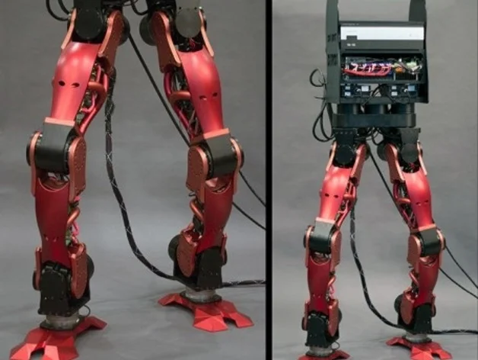**Design Flow**

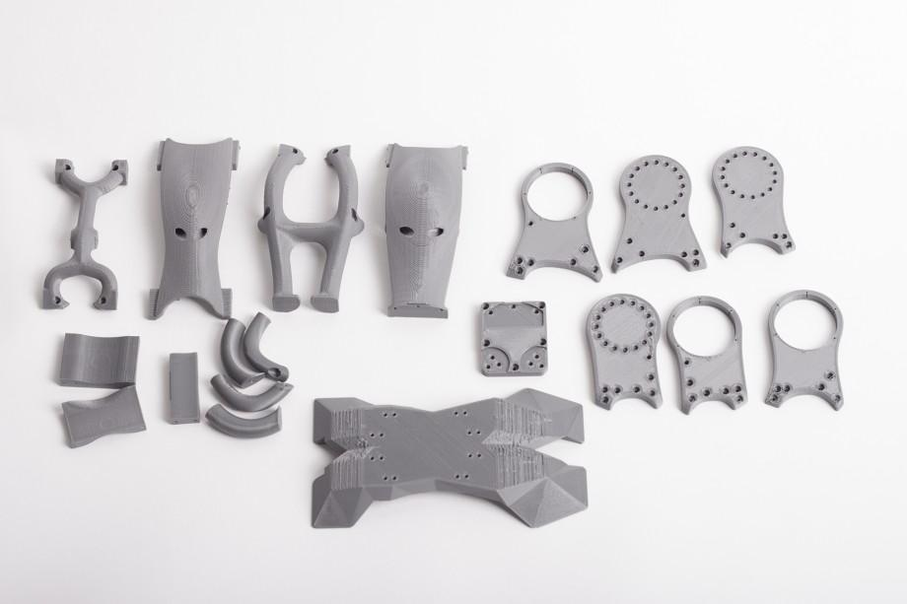

**Simulation and Outcome**

This is the humanoid robot design, also known as [DyRoS](http://dhrc.snu.ac.kr/project/humanoid-robot-design/), produced through CNC machining after using the invaluable process of 3D design and 3D printing to form a visualization of the structure, as well as allow for testing.

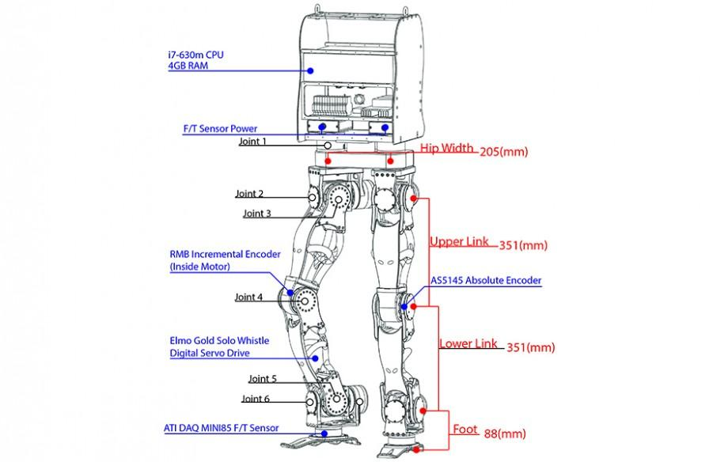

**Methodology**

3D printing is any of various processes in which material is joined or solidified under computer control to create a three-dimensional object, with material being added together (such as liquid molecules or powder grains being fused together), typically layer by layer.3D printed objects can have a very complex shape or geometry and are always produced starting from a digital 3D model or a CAD file.

**3D printer(ANET A8)**

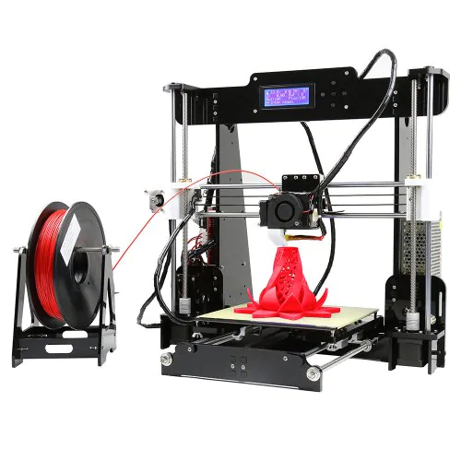

Anet A8 3D Printer DIY Printer is a useful yet affordable 3D printer for beginners and enthusiasts alike with its capable extruder and hotbed. It is made by using Acrylic or Aluminium Composite (Aluminium surface with plastic structure)

* XY Axis Accuracy: 0.012mm Z-Axis Accuracy: 0.004mm ,
* Max Print Size: 220x220x240mm ,
* Heating Plate Material: Aluminium .
* Printable Materials: PLA, ABS, TPU, Wood Poly, PVA, PP, Nylon, Luminescent
* Filament Diameter: 1.75mm .

**Filaments**

The raw material that keeps your printer printing is called filament. There’s an abundance of 3D printer filament choices available to you. Here, we’ll cover the common “daily driver” filaments like PLA and ABS.

**PLA**

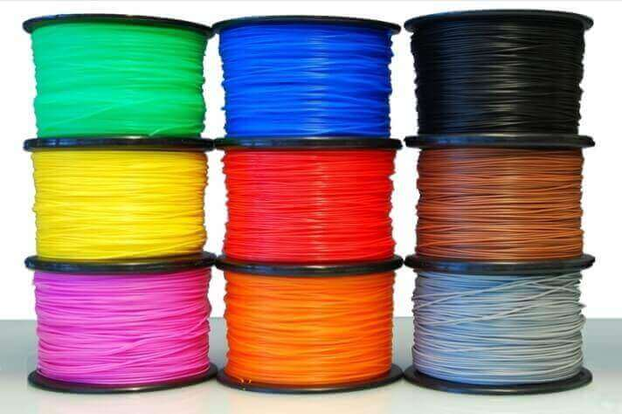

Poly(lactic acid)or poly lactic acidor polylactide(PLA) is a biodegradable and bioactive [thermoplastic](https://en.wikipedia.org/wiki/Thermoplastic)[aliphatic](https://en.wikipedia.org/wiki/Aliphatic)[polyester](https://en.wikipedia.org/wiki/Polyester)derived from [renewable](https://en.wikipedia.org/wiki/Renewable_resource)biomass, typically from fermented plant starch such as from [corn](https://en.wikipedia.org/wiki/Corn_starch), [cassava](https://en.wikipedia.org/wiki/Cassava), sugar caneor [sugar beet pulp](https://en.wikipedia.org/wiki/Beet_pulp).

**ABS**



Acrylonitrile butadiene styrene (ABS) ranks as the second most popular 3D printer filament, after PLA. But that just means it’s the second most commonly *used*. With respect to its material properties, ABS is actually moderately superior to PLA, despite being slightly more difficult to print with. It’s for this reason that ABS is found in many manufactured household and consumer goods, including LEGO bricks and bicycle helmets.

**Requirement and Specifications**

The humanoid robot is made by using 3D printing so it requires 3D printer to print files.

* 3D Printer
* Stepper motor
* Arduino
* motor controllers
* Raspberry pi , Pi-camera
* PLA

**Specifications:**

* It has been designed as a torque-controlled robot with 12 DOF, with motors directly connected to the joint with a low gear ratio. 'This configuration allows for compliant motion and good back-variability without using joint torque sensors.
* All in all, the lower body weighs just '38.795kg, slightly under the estimated 40kg used in the motor selection and simulation.
* It will be able to perform basic human tasks like walking or moving.
* Able to recognize object to walk without touching them.

**Software Specifications**

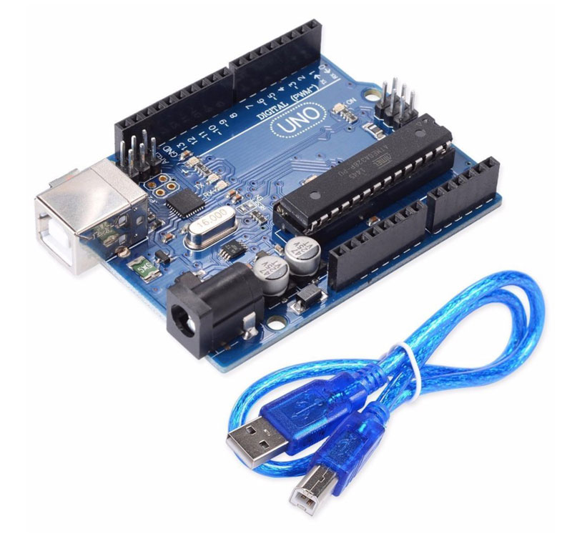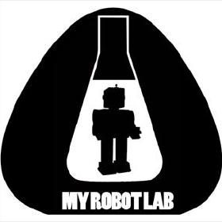

**Arduino**

Arduinois an [open-source hardware](https://en.wikipedia.org/wiki/Open-source_hardware)and [software](https://en.wikipedia.org/wiki/Open-source_software)company, project and user community that designs and manufactures [single-board microcontrollers](https://en.wikipedia.org/wiki/Single-board_microcontroller)and [microcontroller](https://en.wikipedia.org/wiki/Microcontroller)kits for building digital devices and interactive objects that can sense and control both physically and digitally. Its products are licensed under the [GNU Lesser General Public License](https://en.wikipedia.org/wiki/GNU_Lesser_General_Public_License)(LGPL) or the [GNU General Public License](https://en.wikipedia.org/wiki/GNU_General_Public_License)(GPL), permitting the manufacture of Arduino boards and software distribution by anyone. Arduino boards are available commercially in reassembled form or as [do-it-yourself](https://en.wikipedia.org/wiki/Do-it-yourself)(DIY) kits.

**Myrobotlab**

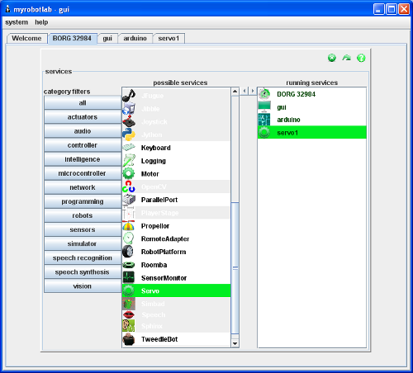

Myrobotlab is a open source Java service based framework for robotics and creative machine control.

The services myrobotlab include machine vision from Javacv/Opencv, speech recognition from Sphinx 4, text to speech from FreeTTS, Motor control, Servo control, GUI control and microcontroller comminication. Third party services are wrapped in myrobotlab Service wrappers and added to the framework.

**Myrobotlab Text to Speech:**

Speech synthesis is the artificial production of human [speech](https://en.wikipedia.org/wiki/Speech). A computer system used for this purpose is called a speech computer or speech synthesizer, and can be implemented in [software](https://en.wikipedia.org/wiki/Software) or [hardware](https://en.wikipedia.org/wiki/Computer_hardware) products. A text-to-speech (TTS) system converts normal language text into speech.

The Speech service is used to generate speech from textual input. It is a Proxy service since there are several possible implementations which could be used. Mary Speech, Acapela Speech & Google Speech can provide the needed implementations, while the Speech service offers a common interface.

**For more information visit:**

http://myrobotlab.org

**System Design**

The robot uses 3d printing for designing and for electronic part it uses pcb designing , stepper motors and power electronics for moving various joints in the body.

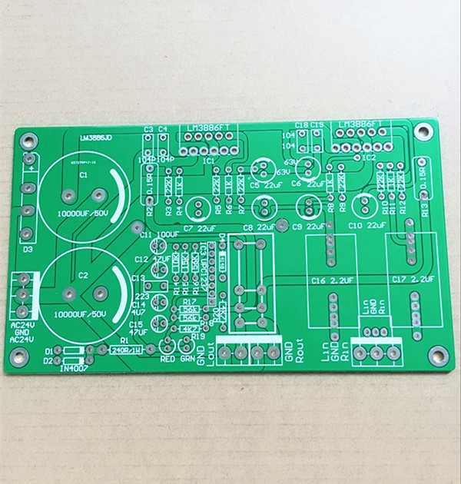**Stepper motor**

A stepper motor, also known as step motor or stepping motor, is a [brushless DC electric motor](https://en.wikipedia.org/wiki/Brushless_DC_electric_motor) that divides a full rotation into a number of equal steps. The motor's position can then be commanded to move and hold at one of these steps without any [position sensor](https://en.wikipedia.org/wiki/Rotary_encoder) for [feedback](https://en.wikipedia.org/wiki/Feedback) (an [open-loop controller](https://en.wikipedia.org/wiki/Open-loop_controller)), as long as the motor is carefully sized to the application in respect to [torque](https://en.wikipedia.org/wiki/Torque) and speed.

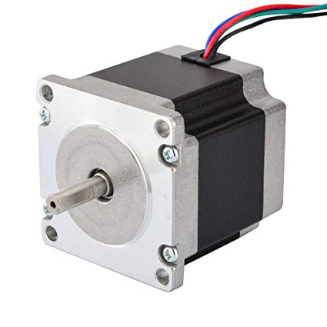

**3D printed Motor**

The motor is a redesign based on the learnings from the make Sea For the design I've used Fusion 360, for 3d-printing repetier software. The referenced videos above show additional information: general demo, building and assembly instructions.

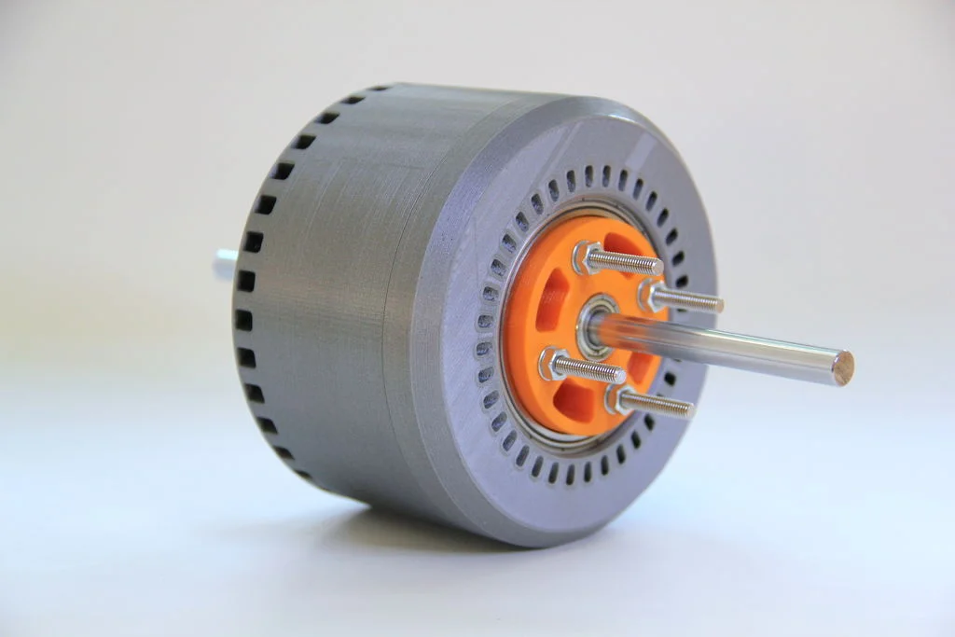

**Brushless 3D printed motor**

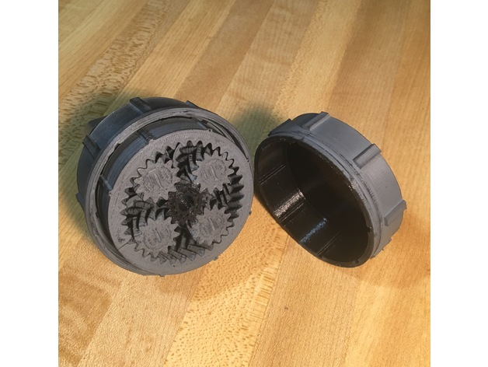

# **Compound Planetary Gear Box**

This automatic transmission uses a set of gears, called a compound planetary gear set, that looks like a single planetary gear set but actually behaves like two planetary gear sets combined. It has one ring gear that is always the output of the transmission, but it has two sun gears and two sets of planets**.**

**Project hardware**

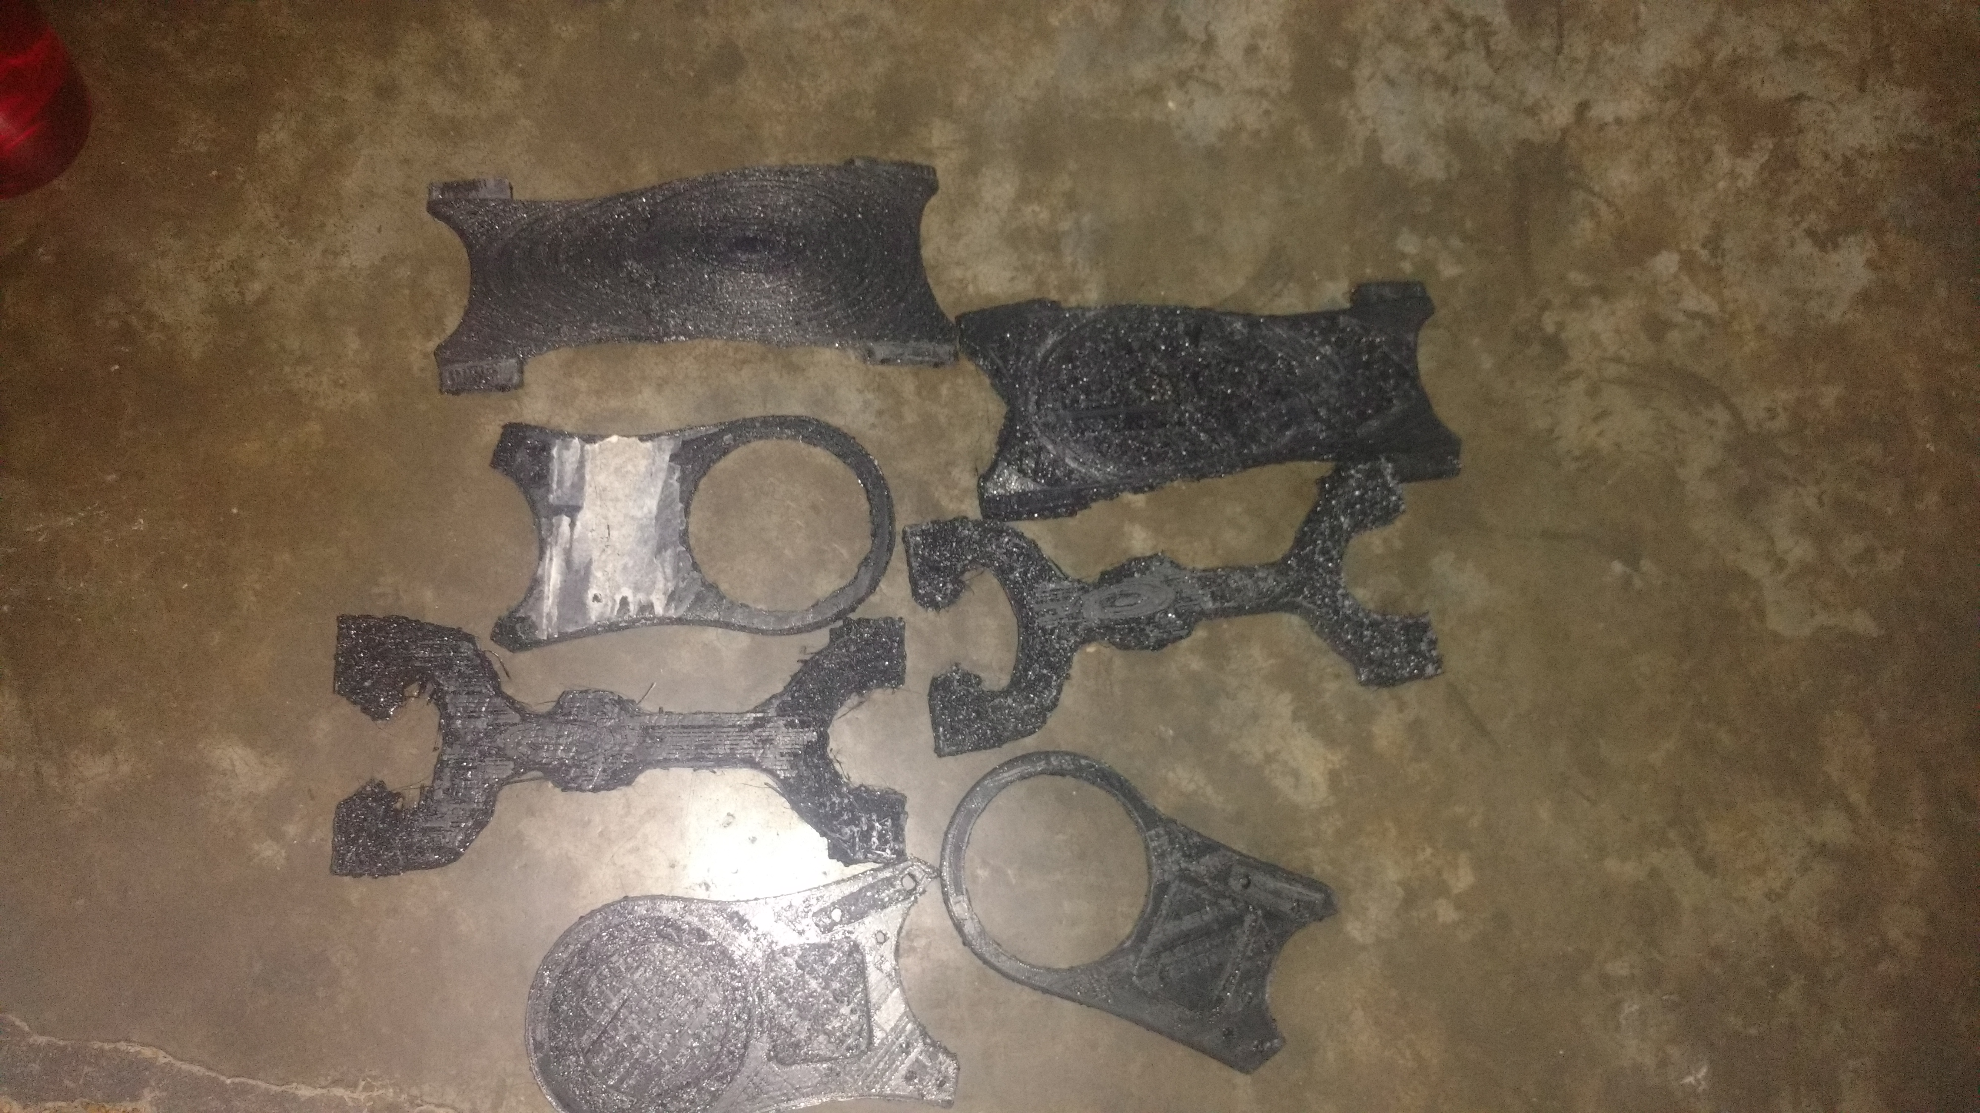

**3D Printed Parts**

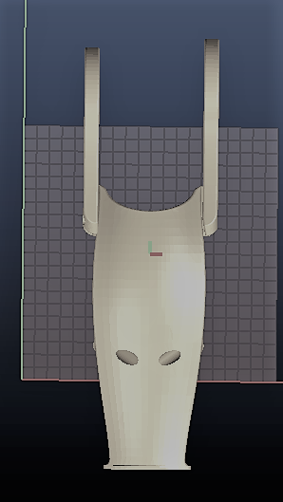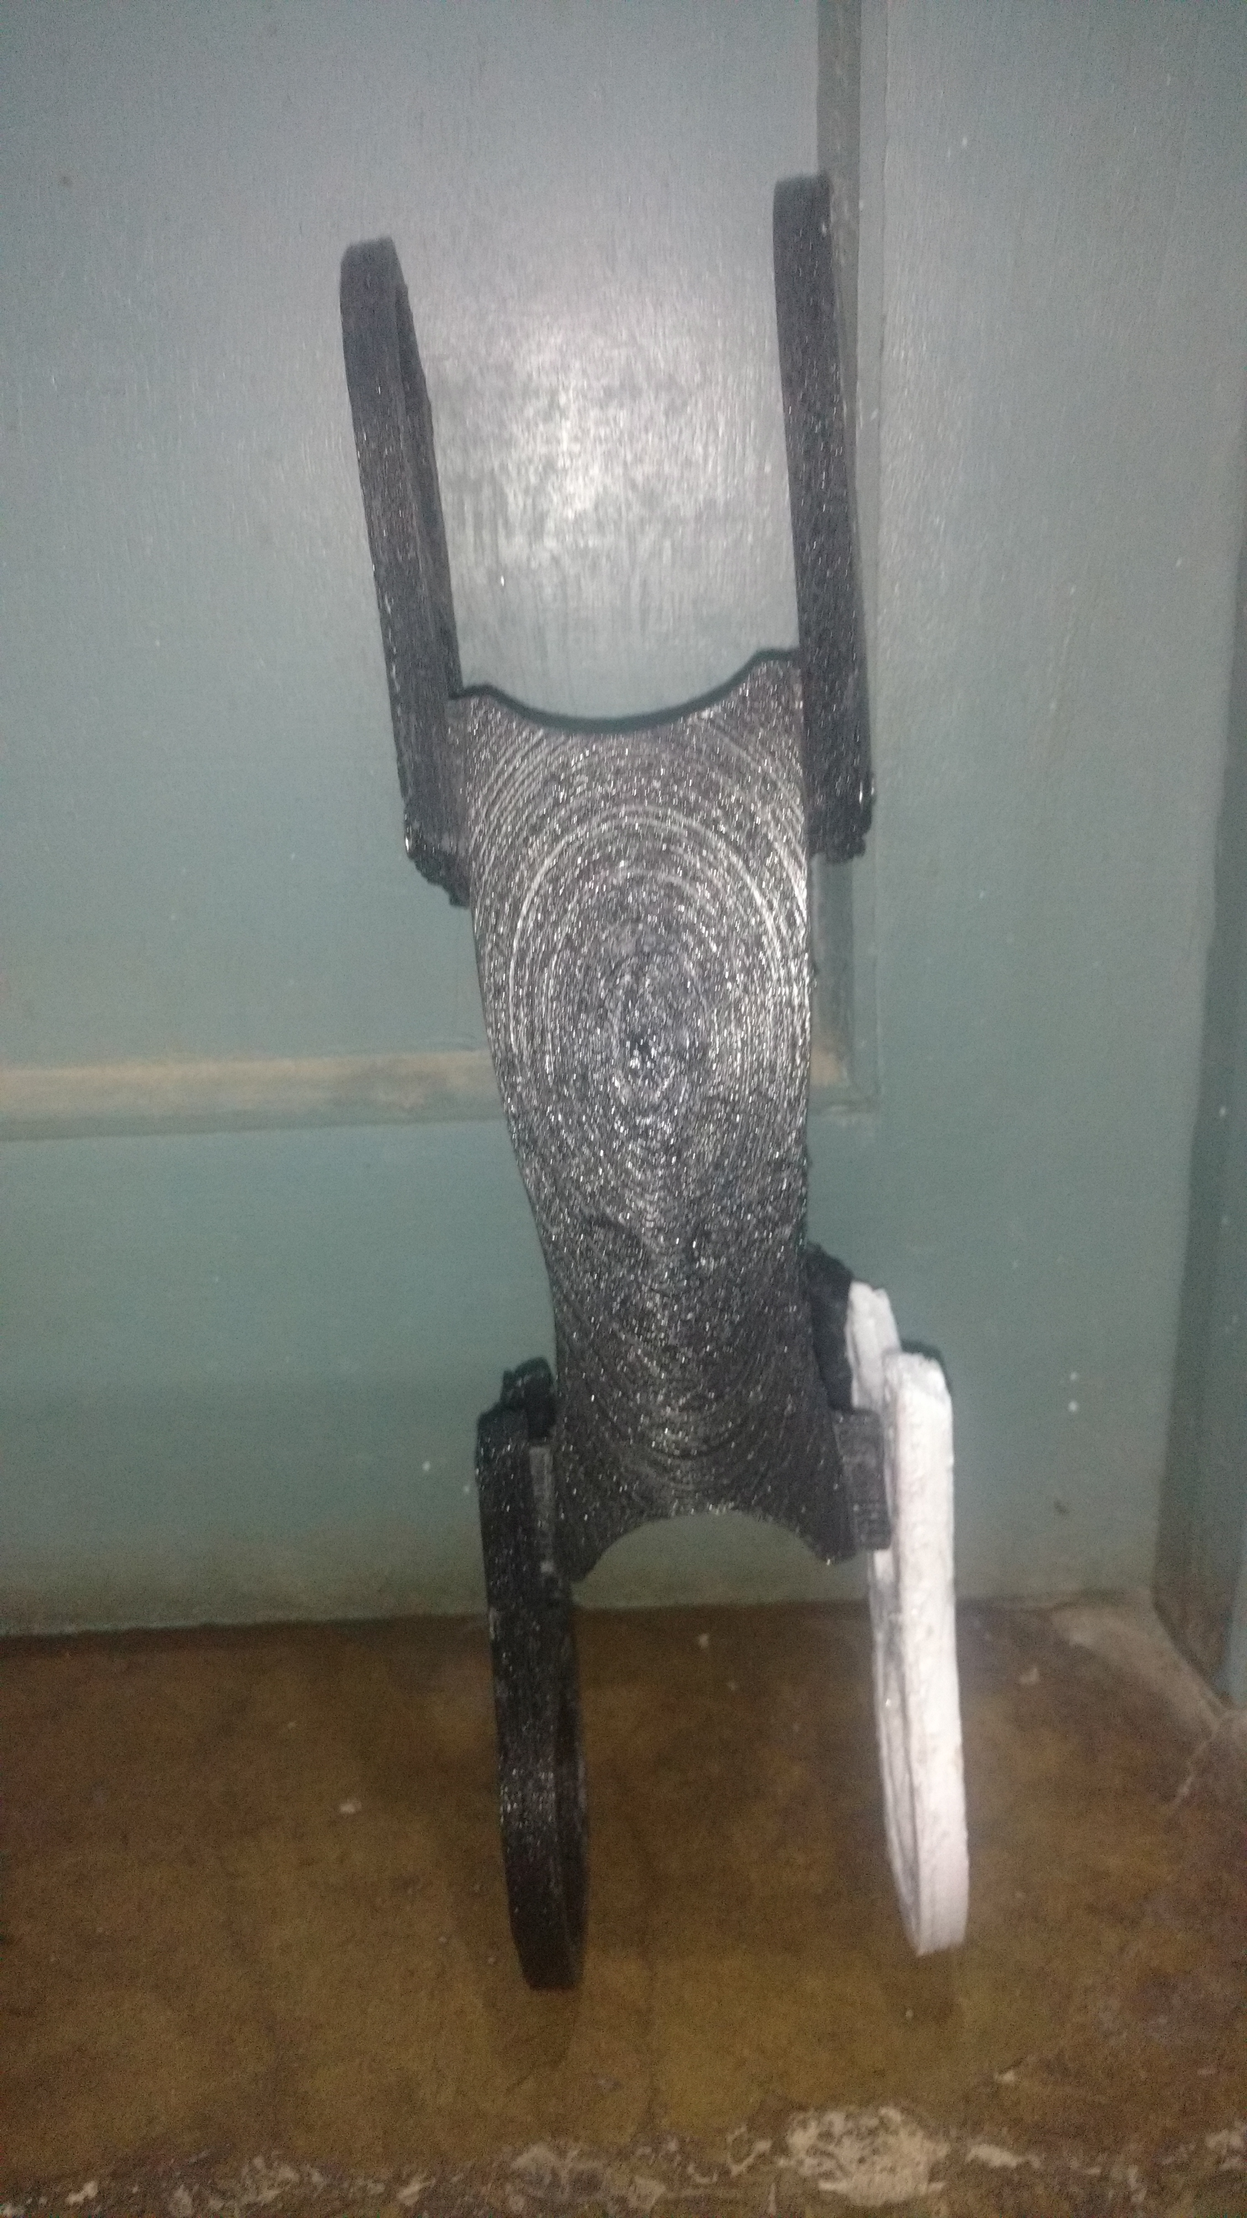

**Lower Leg Upper Leg**

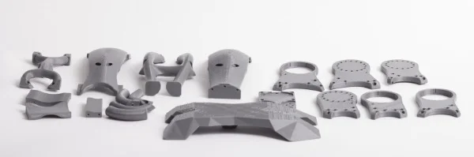

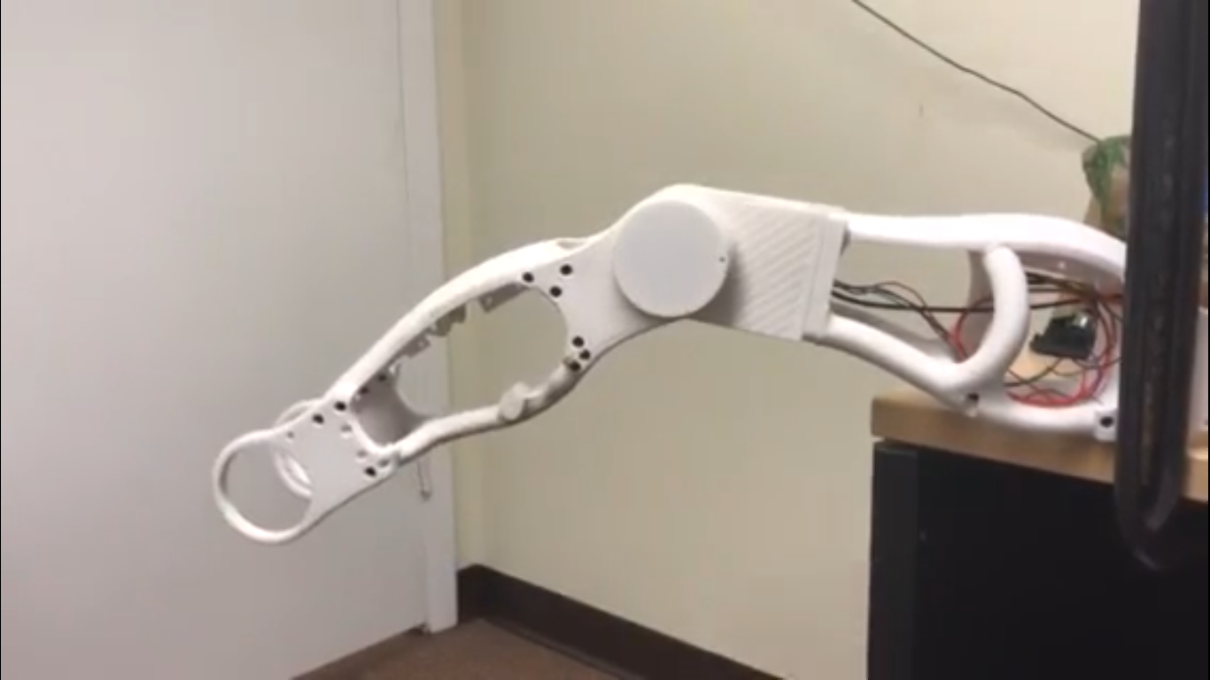

**Conclusion and Future Scope**

**Conclusion**

Robotics is fast entering into the industrial space, and many other utilities application it is but natural that a lot of employment and entrepreneurship opportunities are opening up for people who wish to enter this growing and exciting field. It is evident from the above provided details that the robots have proved time and again that they can do the impossible. Man’s short stay in this planet is influenced by these machines created by the human brain. Hopefully in a few years these man-made machines or the so called “Brain child of mankind” will find its path along every walks of human life.

**Future Scope:**

* Can be used at railway stations , police stations , airports so that people can interact with it and ask about their quarries.
* Can be used at industries and homes for cleaning and mopping floors.
* Can be used at hospitals for taking care of old-age people’s and children's.
* Can be used at nuclear power-plants for detecting faults.
* Ultimate helpers in case of natural disasters.
* Can be used in robotic surgery.

**References**

* [tinkercad.com](http://www.tinkercad.com/)
* inmoov.fr
* https://www.thingiverse.com/thing:564388
* [https://3dprint.com/26939/dyros-3d-printed-robot](https://3dprint.com/26939/dyros-3d-printed-robot/)
* GitHub.com
* autodesk.com
* 3dprintinghub.com
* amazon.com
* myrobtolab.org
* <https://all3dp.com/3d-print-brushless-motor>
* <https://www.thingiverse.com/thing:2054378>

**Cost Analysis**

|  |  |  |  |
| --- | --- | --- | --- |
| **S. No.** | **Component / Material** | | **Price (in Rs.)** |
| 1. | PLA | | 6000 |
| 2. | Arduino | | 1000 |
| 3. | Raspberry pi | | 3000 |
| 4. | Pi Camera | | 500 |
| 5. | motor-controller | | 3000 |
| **Total** | | **Rs13500/-** | |

**ECE ARCHIVES PROJECT SUBMISSION FORM**

Project Code: **CU/ECE/20____/Sem____/UID______________ (To be filled by Office)**

Project Name: ________________________________________

Team Members:

|  |  |  |  |  |
| --- | --- | --- | --- | --- |
| **S. No.** | **Name** | **UID** | **Semester** | **Contact No.** |
| 1. |  |  |  |  |

**Section to be filled by Project Mentor**

**Status (Please tick, whichever applicable)**

|  |  |  |  |  |  |
| --- | --- | --- | --- | --- | --- |
| Working |  | | Not Working | |  |
| **Marks Awarded** | | **60** | |  | |

Project Mentor Details:

Name _______________________________ Employee ID _______________

Sign ________________________________ Date ______________________

**Section to be filled by Project Examiner(s)**

**Status (Please tick, whichever applicable)**

|  |  |  |  |
| --- | --- | --- | --- |
| Working |  | Not Working |  |

Project Examiner Signatures:

Internal _______________________________ Employee ID ______________

External _______________________________ Employee ID ______________

Date __________________________________